Instructions for Taking Backgate Measurements with Keithley 2231A

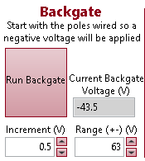

1. Wire the power supply (2231A) so a negative backgate voltage will be applied in the beginning.
2. Choose a file name (preferably with sensor name)
3. Check Save File

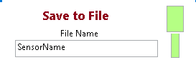



1. Select range, and increment.

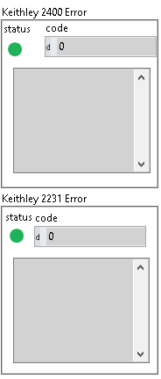

1. Confirm no errors on Keithley 2400 and 2231
2. Click Run Backgate

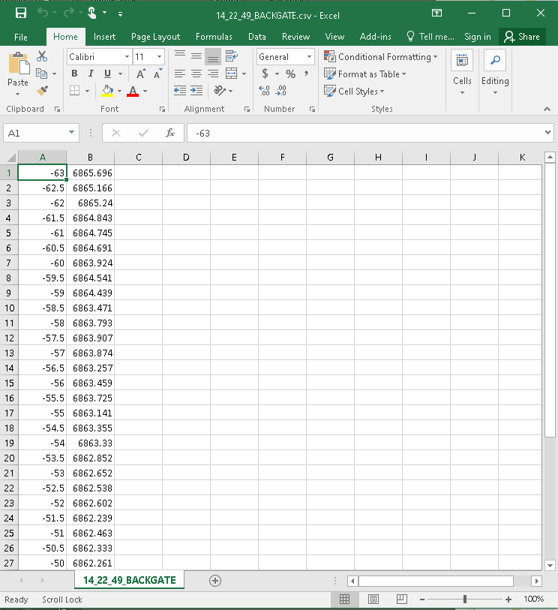The IV curve graph will begin plotting Resistance vs Backgate Voltage, and an excel file with the data will be saved in the application /TestData folder, which can be accessed from the desktop.